

**Project Name: Coaching Management System**

**Course name: Introduction to Database**

**Course Teacher: Rezwan Ahmed**

**Section: C**

**Submitted by :**

**Name: ID:**

**1. Sultan,Tofayet 19-40385-1**

**2. Hossen,Md Monaem 18-38645-3**

**3. Islam,Md.Masayeakh 19-40506-1**

**4. Shalah,M.A. 19-40489-1**

**CONTENTS:**

**PART-A:**

**Overview**

**ERD Diagram**

**Normalization**

**Screenshot of every table**

**Query**

**PART-B:**

**Summary**

**Details experience**

**01000000000000**

**PART-A**

**Overview**

**In this management system we want to create a coaching management system what we can use for managing this whole system by the help of relation of different table .So,here it is-**

**ER-Diagram:**

|  |
| --- |
|  |

**NORMALIZATION  
Expert :** (Sub_id , Sub_name , T_id , T_name , Gender , Address , Email)

**1NF :** Email is a multivalued attribute.

**2NF :** Sub_id , Sub_Name

T_id , T_name , Gender , Address , Email

**3NF :** Sub_id , Sub_Name

02

T_id , Address , Email

G_id , T_Name , Gender

Table for Expert :

1. Sub_id , Sub_Name
2. T_id , Email
3. G_id , T_Name , Gender
4. N_id , Sub_id , T_id

**Manage :** (T_id , T_Name , Gender , Address , Email , M_id , M_Name , Phone)

**1NF :** Email and phone are multivalued attribute.

**2NF :** T_id , T_Name , Gender , Address , Email

M_id , M_Name , Phone

**3NF :** G_id, T_name ,Gender

M_id, M_name, Phone

T_id, Address, Email

Table for Manage :

1. T_id , Address , M_id
2. M_id , Phone , Acc_id , S_id

**Gives Salary :** (M_id , M_Name , Phone , Acc_id , Phone , Acc_name )

**1NF :** Phone are multivalued.

**2NF :** M_id , M_Name , Phone.

Acc_id , Acc_Name , Phone.

**3NF :** No transitive dependency.

Table for Gives Salary :

1. M_id , M_name, Acc_id  
2.Acc_id, Acc_name  
  
Pay (Acc_id, Acc_name, phone, pay date,due,amount,s_id,s_name,address,phone,Age,DOB)  
  
1NF: Phone are multivalued  
2NF : Acc_id,Acc_name,phone

03

Pay_id, pay date,due,amount

S_id,S_name,address,phone,Age,DOB  
3NF: Acc_id,Acc_name,phone  
 S_id,S_name,address,phone  
 A_id,Age,DOB  
 Pay_id,Pay_date,due,amount  
  
Table:  
S_id,S_name,address,Acc_id  
A_id,Age,DOB  
Pay_id,pay_date,due,amount  
  
  
Teach: (T_id,T_name,gender,address,email  
 s_id,S_name,address,phone,DOB,age)  
1NF: phone and email multivalued  
2NF: T_id,T_name,gender,address,email  
 S_id,S_name,address,phone,DOB,age  
3NF: T_id,address,email  
 G_id,T_name,gender  
 S_id,S_name,address,phone  
 A_id,DOB,age  
  
Table:  
 St_id,T_id,S_id  
  
Learn: (sub_id,sub_name,s_id,s_name,Age,Address,phone,DOB)  
1NF: phone multivalued  
2NF: sub_id,sub_name  
 s_id,s_name,address,phone,DOB,Age  
3NF: sub_id,sub_name  
 s_id,s_name,address,phone  
 A_id,DOB,Age  
  
Table: SS_id,sub_id,s_id

**Table:**

1. ***Subject:*** Sub_id, Sub_Name
2. ***Accountant****:* Acc_id, Acc_name
3. ***Manager****:* M_id, M_name, Acc_id
4. ***Tutor:*** T_id, Address, M_id
5. ***Student:*** S_id, S_name, Address,Acc_id
6. ***Manager 1****:* M_id, Phone, Acc_id, S_id
7. ***Tutor-1:*** T_id, Email
8. ***Age:*** Age_id, age , DOB
9. ***Payment:*** Pay_id, Pay_date , Due, Amount, S_id, Acc_id
10. ***New 1 :*** G_id, T_name ,Gender
11. ***New_2 :*** N_id, Sub_id , T_id
12. ***New 3 :*** ST_id, T_id , S_id
13. ***New 4 :*** SS_id , Sub_id , S_id

Table 1:

**Subject**

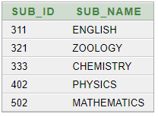

Table 2

**Accountant**

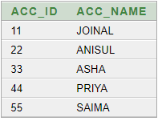

Table 3:

**Manager**

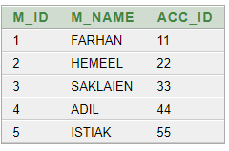

Table 4 :

**Tutor**

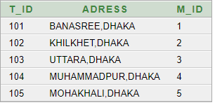

Table 5

**Student**

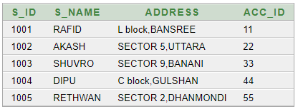

Table-6

**Manager1**

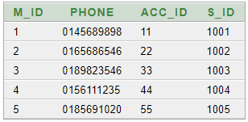

Table -7

**Tutor -1**

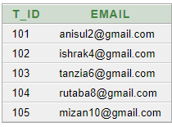

Table-8

**Age**

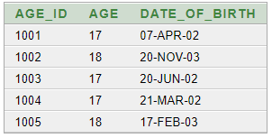

Table-9

**Payment**

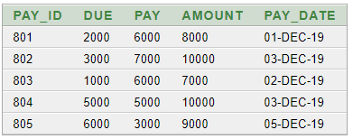

Table-10

**New-1**

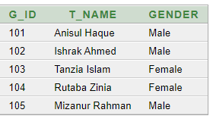

Table-11

**New-2**

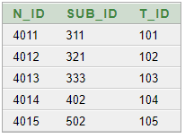

Table-12

**New-3**

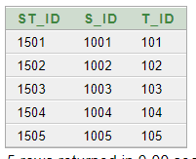

Table-13  
**New-4**

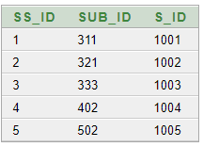

**Queries:**

**(01)Q**. Find out the total pay and due.

**Ans:** **Select Sum(due),Sum(Pay) from payment;**



**(02)Q.** Find out the manager id, name and account id whose name start with “S” or end with “K”

**Ans:**  **Select M_ID,Acc_ID,M_Name from Manager where M_name like'S%' or M_Name like '%K';**

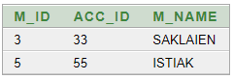

**(03)Q**.Find out the student id ,name and account id in descending order.

**Ans:** **Select S_ID , Acc_Id ,S_name from student order by S_ID DESC;**

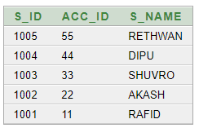

**(04)Q**: Display pay,amount from payment table where amount is greater than pay id 801’s amount.

**ANS: Select pay,amount from payment**

**Where amount>(select amount from payment where pay_id = 801);**

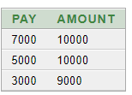

**(05)Q**. Display Date of birth, age from AGE table whose age is equal to maximum age**.**

**ANS: select date_of_birth,age from age**

**where age=(select max(age) from age);**

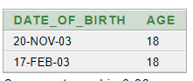

**(06)Q.** Display all from MANAGER table whose account id is equal to Manager name ’FARHAN’

**ANS:**

**select * from manager**

**where acc_id =(select acc_id from manager where m_name='FARHAN');**

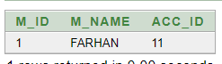

**(07)Q**. Find out pay,pay_id,Pay_date from Payment table whose due is higher than the average due.

**ANS:**

**select pay,pay_id,pay_date from payment**

**where pay<any(select avg(due) from payment group by pay_id );**

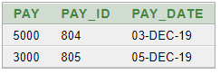

**(08)Q.** Display all from student table whose name is equal to address sector 5, Uttara

**ANS :**

**select * from student where s_name = any (select s_name from student where address = 'SECTOR 5,UTTARA')**



**(09)Q.** Display account id, accountant, manager, manager name whose gives the payment to his manager.

**ANS:**

**Select Accountant.Acc_id , Accountant.Acc_name , Manager.M_id,Manager.M_name**

**from Accountant, Manager where Accountant.Acc_id = Manager.Acc_id;**

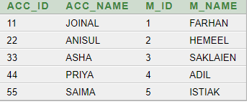

**(10)Q.** Create a view to display due,amount and pay date whose pay id is 804

**ANS:**

**Create View Learner_Payment as**

**Select due,amount,pay_date from payment where pay_id = 804;**

**Select * from Learner_Payment;**



**Relational Algebra:**

1. Find Out Student id,name whose Adress is Sector 9,Banani

Ans:

ΠS_ID,S_name (σAdress=Sector 9,Banani (Student))

2. . Find Out the total pay and due.

Ans: Πsum(due),sum(pay) (Student)

3. Find Out The tutor name who are males.

Ans: ΠT_name (σGender=’Male’ (New1))

4. Find Out Students name whose City is Dhaka.

Ans: ΠM_id , Acc_id , M_Name (σname like(S%) ∨ like(%K) (New1))

5. Find Out Student id,Name and account id in descending order

Ans: ΠS_id , S_Name, Acc_id (*T*S_id,Acc_id(Student))

6. Display pay,amount from payment table where amount is greater than pay id 801’s amount.

Ans: Πpay , amount (σamount >(amount of pay_id =801) (Payment))

7. Display Date of birth, age from AGE table whose age is equal to maximum age**.**

Ans: ΠDate_of_birth , age (σ age =max(age) (AGE))

8. Display all from MANAGER table whose account id is equal to manager name ’FARHAN’

Ans:

ΠM_id, M_name, Acc_id (σM_Name=’FARHAN’) (Manager))

9. Find out pay,pay_id,Pay_date from Payment table whose due is higher than the average due Ans:

Πpay, pay_id, pay_date (σdue>avg(due) (Payment))

10. **.** Display Student id, Student name, Age and their date of birth.

Ans:

ΠS_id , S_name , Age, Daate_of_birth (Student×Age)

PART-B

Summary:

Here the project coaching Management System is a database which provides a platform for all age groups of students to learn about different subjects from different tutors. Students pay their tution fees to the accountant. Tutors are selected by students by their own choice. There are managers to manage the tutors who is expert in specific subject for students recommendation.  
In this tutor Management System, a student can be taught by different types of tutors. And also a tutor can teach multiple students. A student is identified by a student ID. Student name, Date of Birth, age, address and phone are also stored where phone is multivalued attributes. Tutor is identified by tutor ID, tutor name, gender, address & email. Email also a multivalued attributes. Different types of subjects are identified by their subject id. One tutor can expert in many subjects. Besides, so many students can learn many subjects. Students pay their payment to the accountant. When they pay their payment payment date, amount and due should be stored. So it is easy to find out the student who has due and who pay full amount. Accountant has also his id, phone number where number is multivalued and id is a primary key. So student can recognised the accountant those they make payment. One Manager manages many tutors. Managers are identified their name, id which is primary key and phone number which is also a multivalued attributes. Every Accountant gives the collected payment to his manager.

Learning experience:Over the semester we learned a lot about database management system and finally we tried to do something by ourself as a project where we learned more and more when we tried to do this.

Problems:We didn’t face any problem when we started the project .we completed our ERD diagram and normalization smoothly but when we started to create the table and set up a relation between them we faced some difficulties because of we did this for the first time .

Achievement:From the side of achievement we can say that we did something what we can use in future as an experience of create a project.

Outcome:We completed a whole project for a tutor management system.

Future plans:In future we can use this kind of project or this type of project for so many institutions.

Thoughts/Comments:There was some difficulties as we did that for the first time but by the help of every group members we solved it .So there was a great experience for us what we can use in future.